|  |  |  |  |  |  |
| --- | --- | --- | --- | --- | --- |
| |  |  |  | | --- | --- | --- | | **Kingdom of Saudi Arabia**  **Ministry of Education**  **University of Jeddah**  **College of Computer Science and Engineering**  **Department of Computer Science and Artificial Intelligence** |  | **المملكة العربية السعودية**  **وزارة التعليم**  **جامعة جدّة**  **كلية علوم وهندسة الحاسب**  **قسم علوم الحاسب والذكاء الاصطناعي** | |  |  |

|  |
| --- |
| **Lab 1** |
| **CCAI323 Machine learning** |
| **First Semester 2023/2024**   |  |  | | --- | --- | | **Lab Date/Time: xxx**  **Lab assignment submission Date/Time: xxxx** |  | | **Student Name: _________________________________**  **Student ID: _________________________________** | | |

|  |  |
| --- | --- |
| **Instructor Name** | **Section** |
|  |  |

**Instructions**:

The lab assignments must be submitted before the allocated Date/Time.

The lab assignments must by uploaded to blackboard.

Plagiarism will be punished according to university rules.

|  |  |
| --- | --- |
| **PLO/CLO** | **SO** |
|  |  |

|  |  |  |  |
| --- | --- | --- | --- |
|  |  | **Max Score** | **Student Score** |
| **PLO S2 / CLO 2 / SO 2** | **Questions 1,2** | **8** |  |
| **Total** | |  |  |

**Lab1 overview content:**

|  |  |  |  |
| --- | --- | --- | --- |
| Title | Description | Jupter notbook | Lab Questions |
| Part A: review of basic | | | |
| NumPy Basic Demo | Examples of basic numpy functionality | NumpyBasic.ipynb | Question1 |
| NumPy Matrix Operations Demo | Examples of matrix operations numpy functionality | NumpyMatrixOperations.ipynb |
| Matplotlib Basic Demo | Examples of basic matplotlib plotting functionality | MatplotlibBasic.ipynb | Question2 |
| Matplotlib Advanced Demo | Examples of matplotlib scatter plot and animation functionality | MatplotlibAdvanced.ipynb |

**Review of basics:**

1. Numpy matrix operation:

NumPy/Numpy numpy is a Python package for scientific computing.

* Key structure is multi-dimensional numpy array
* numpy functions manipulate these arrays
* Can perform standard matrix and vector operations
* Can perform operations on entire array without explicit looping
* Course codes use the numpy arrays for holding datasets and employ numpy functionality for clustering and dimension reduction algorithms

**Key Numpy Commands and Functions:**

|  |  |
| --- | --- |
| Operation | Numpy functions |
| Array creation, indexing, and size | arange, array, size |
| Componentwise operations: addition,  multiplication, scalar multiplication and broadcasting |  |
| Functions | absolute, square |
| Finding entries | where |
| Concatenating and reshaping arrays | concatenate, reshape |
| Sum entries of array | sum |
| Maximum of entries | max, argmax |
| Creating array of zeros | zeros |
| Creating arrays of random numbers: setting seed, from uniform distribution, from normal distribution, generating random integers, choosing randomly from array | random.seed, random.rand, random.randn, random.randint, random.choice |

**Numpy Functions for Matrix Operations:**

|  |  |
| --- | --- |
| Operation | Numpy functions |
| Transpose | .T attribute |
| Flip matrix up/down or left/right | flipud, fliplr |
| Dot product | dot |
| Matrix multiplication | matmul |
| Matrix inverse | linalg.inv |
| Matrix determinant | linalg.det |

**Download Jupyter Notebook for demo:**

* NumpyBasic.ipynb
* NumpyMatrixOperations.ipynb

**Question 1: [PLO K1 / CLO 1 / SO 1] [6 marks]**

**Q1.1:**

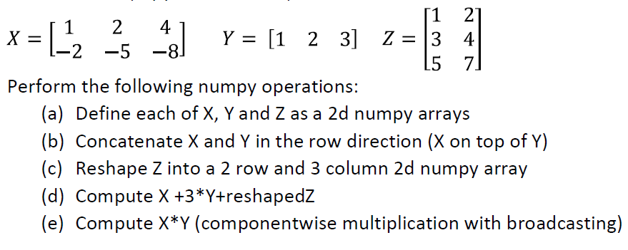Let:

**Q1.2:**

**Let:**

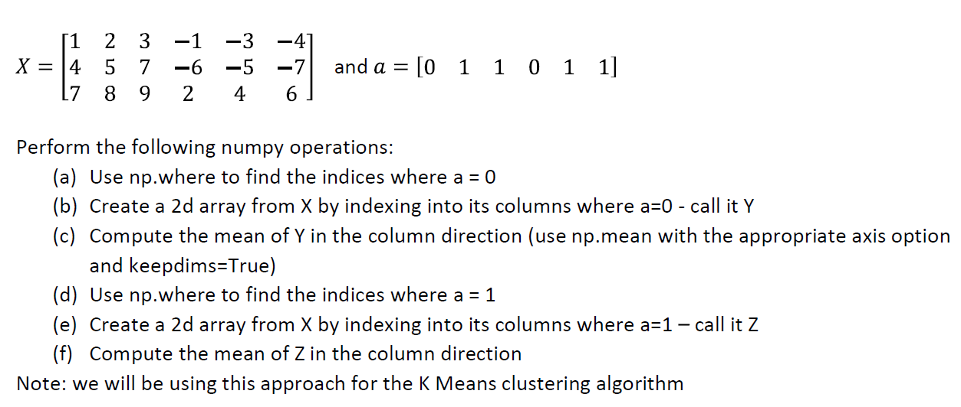

**Q1.3:**

Let:

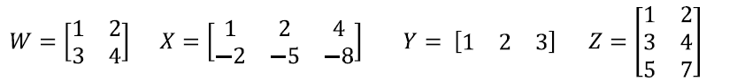

**Compute the following (all multiplications here are matrix multiplications):**

$X+Y$

$WY$

$Z+Y^{T}$

$XZW^{-1}$

$X+Z^{T}$

2. **ZX**
${X^{T}Z}^{T}$

3. Matplotlib Cluster plot and animation Demo (self_study):

Matplotlib is a Python package for plotting

See following site for details: <https://matplotlib.org>

Matplotlib has Matlab like interface.

**Matplotlib Basics: Commands and Functions**

|  |  |
| --- | --- |
| Operation | matplotlib functions |
| Creation of figure and basic plotting of data and adding titles, labels, and legends | figure, plot, legend, title, xlabel, ylabel, show |
| Multiple plots | subplots |
| Object oriented approach | subplots |

**Matplotlib Advanced: Commands and Functions:**

|  |  |
| --- | --- |
| Operation | matplotlib functions |
| Colormeshuseful for plotting images | pcolormesh |
| Scatter plot | scatter |
| Animation of scatter plot | Create a function to generate each frame of animation  Use FuncAnimationto call function and create animation |

**Matplotlib Colormaps:**

* Load colormaps from matplotlib (examples shown below)
* Can choose color using cm.name(value)
* name: is colormap name (flag, prism, ocean, etc)
* Value is in [0,1] 0 gives color on left and 1 gives color on right

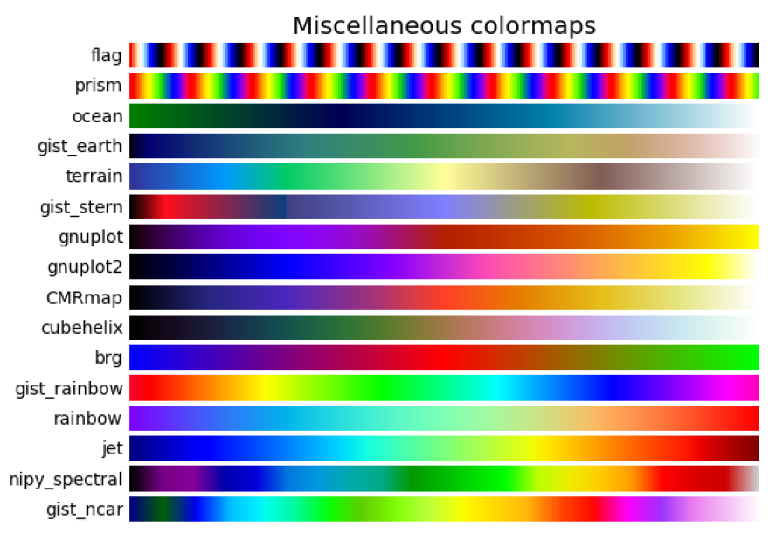

For creating MP4 Files from Matplotlib Animations, ffmpeg used to convert matplotlib animations into mp4 files

**Download Jupyter Notebook for demo:**

* MatplotlibBasic.ipynb
* MatplotlibAdvanced.ipynb

**Question 2: [PLO K1 / CLO 1 / SO 1] [2 marks]**

**Q2.1: Using numpy and matplotlib functionality plot the following functions**

**for x between -5 and 5.**

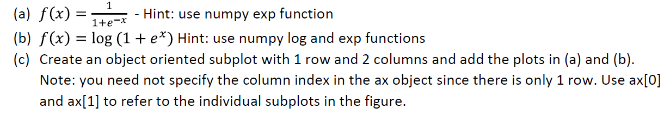

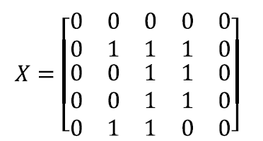**Q2.2: (optional)**

(a) Consider the following matrix:

Plot using pcolormesh. What digit is it? (You will need to use flipud)

(b) Create the matrices for digits 3 and 6 and plot using pcolormesh.

**Q2.3: (optional)** The goal of this problem is to create an animation that combines the 2 animations in the demo in MatplotlibAdvanced.ipynb.

* + Change colors for a fixed set of 50 randomly chosen data points in 2 dimensions:
  + Change the locations of 5 randomly chosen data points in 2 dimensions:

Hint: create a single figure and create separate scatter objects to hold (1) and (2). Update both scatter objects in the update function. This approach will be used for animation for the K Means algorithm.